**1. What are the various elements of the Excel interface? Describe how they're used.**

**2. Write down the various applications of Excel in the industry.**

**3. On the ribbon, make a new tab. Add some different groups, insert commands in the groups and name them according to their commands added. Copy and paste the screenshot of the steps you followed.**

**4. Make a list of different shortcut keys that are only connected to formatting with their functions**

**. 5. What distinguishes Excel from other analytical tools?**

**6. Create a table and add a custom header and footer to your table**

|  |
| --- |
| **A1.** The following are the basic parts of the Microsoft Excel Window:  1.Quick Access Toolbar  2. File Tab  3. Title Bar  4. Control Buttons  5. Menu Bar  6. Ribbon/Toolbar  7. Dialog Box Launcher  8. Name Box  9. Formula Bar  10. Scroll Bars  11. Spreadsheet Area  12.Leaf Bar  13. Column Bar  14.Row Bar Cells  15. Cells  16. Status Bar  17. View Buttons  18. Zoom control  1. Quick Access Toolbar  This toolbar is located in the upper left corner of the screen. Its objective is to show the most frequently used Excel commands. We can customize this toolbar based on our preferred commands.  2. File Tab  Excel 2007's Office button has been replaced by the File tab. We can click it to check the Backstage view, where we can open or save files, create new sheets, print sheets, and perform other file-related operations.  3. Title Bar  The title bar of the spreadsheet is at the top of the window. It displays the active document's name.  4. Control Buttons  Control buttons are the symbols that are present in the upper-right side of the window, enabling us to change the labels, minimize, maximize, share, and close the sheet.  5. Menu Bar  Under the diskette or save icon or the excel icon (this will depend on the version of the program), labels or bars which enable changing the sheet which is shown. These are the menu bar and contain a File, Insert, Page Layout, Formulas, Data, Review, View, Help, and a Search Bar with a light bulb icon. These menus are divided into subcategories which simplify the distribution of information and analysis of calculations.  6. Ribbon/Toolbar  Each menu bar contains several different elements. On the selection of the menu, a sequence of command options/icons will show on a ribbon. For example, if we select the "Home" tab, we will see cut, copy, paste, bold, italic, underline, and more commands. In the same way; we can click on the "Insert" tab, we will see tables, illustrations, additional, recommended graphics, graphics maps, among others. On the other hand, if we select the "Formulas" option. Insert functions, auto sum recently used, finances, logic, text, time, date, etc.  Ribbon/Toolbar is a set of commands organized into three sections.  Tabs They are the Ribbon's top part, and they include groups of related commands. Ribbon tabs include Home, Insert, Page Layout, Formula, Data.  Groups They organize related commands; the name of each group is displayed below the Ribbon. For example, a set of commands related to fonts or a group of commands related to alignment, etc.  Commands They appear within each group, as previously stated.  7. Dialog Box Launcher  Dialog box launcher is a very little down arrow that is present in the lower-right corner of a command group on the Ribbon. By clicking on this arrow, we can explore more options related to the concerned group.  8. Name box  Show the location of the active cell, row, or column. We have the option of selecting multiple options.  9. Formula Bar  Formula bar permits us to observe, insert or edit the information/formula entered in the active cell.  10. Scrollbars  Scrollbars are the tools that enable us to move the document's vertical and horizontal views. We can activate this by clicking on the platform's internal bar or the arrows we have on the sides. Additionally, we can use the mouse wheel in order to automatically scroll up or down: or use the directional keys.  11. Spreadsheet Area  It is the place where we enter our data. It includes all the rows, cells, columns, and built-in data in the spreadsheet. We can use shortcuts to perform toolbar activities or formulas of arithmetic operations (add, subtract, multiply, etc.). The insertion point is the blinking vertical bar known as the "cursor." It specifies the insertion location of the typing.  12. Leaf Bar  Leaf bar is present at the bottom of the spreadsheet, which says sheet1 is shown. This sheet bar describes the spreadsheet which is currently being worked on. Using this, we can alternate a number of sheets or add a new one as per our convenience.  13. Columns Bar  Columns are a vertically ordered series of boxes across the full sheet. This column bar is located below the formula bar. The letters of the alphabet are used to label the columns. Begin with the letter A to Z, and then after Z, it will continue as AA, AB, and so on. The number of columns that can be used is limited to 16,384.  14. Rows Bar  The row bar is the left part of the sheet where a sequence of numbers is expressed. Begin with number one (1), and further rows will be added as we move the pointer down. There are a total of 1,048,576 rows available.  15. Cells  Cells are those parallelepipeds that divide the spreadsheet into many pieces, separating rows and columns. A spreadsheet's first cell is represented by the first letter of the alphabet and the number one (A1).  16. Status Bar  The status bar is present at the bottom of the window that displays critical information. It also indicates whether something is incorrect or whether the document is ready to be printed or delivered.  This shows the result of the selected digits such as sum, average, count, maximum, minimum, etc.  By right-clicking on the status bar, we can configure the status bar. Any command from the specified list can be added or removed.  17. View Buttons  View buttons are a set of three buttons arranged at the left of the Zoom control, close the screen's right-bottom corner. We can see three different kinds of sheet views in Excel using this method.  Normal View: - Normal view displays the Excel page in normal view.  Page Layout View: - The Page Layout view shows the precise layout of an Excel page it will be printed.  Page Break View: - This displays page break preview before printing.  18. Zoom Control  The zoom control is present at the lower-right side of the window. It enables us to ZOOM-IN or ZOOM-OUT a specific area of the spreadsheet. It is represented by magnifying icons with the symbols of maximizing (+) or minimizing (-).  The various modern versions contain a segment with the icons of more and less, as well as an element that separates the two alternatives, which permits us to manipulate them by clicking on any of these.  On the other side, it also explains in percentage how many times the document has been moved or approached. Microsoft Excel 2019 enables us to zoom out up to 10% and zoom up to 400%. |

**A2.** The most common business uses of MS Excel are business analysis, managing lists of people, operations management, and performance reporting. The software is also handy for office administration, project management, and managing programs, contracts and accounts.

**A3.**

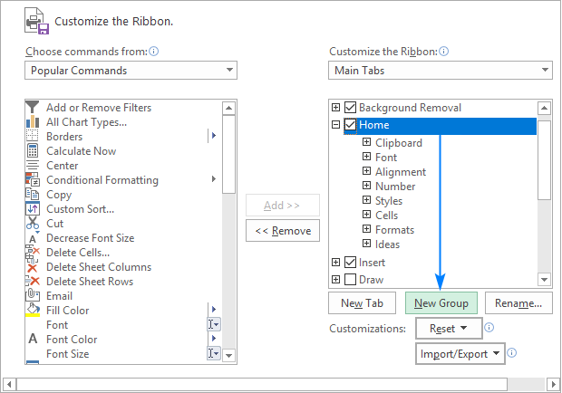

**A4**.

Copy: Ctrl + C

Cut: Ctrl + X

Paste: Ctrl + V

Maximize Window: F11 or Windows logo key  + Up arrow

Open Task View: Windows logo key  + Tab

Display and hide the desktop: Windows logo key  + D

Switch between open apps: Alt + Tab

Open the Quick Link menu: Windows logo key  + X

Lock your PC: Windows logo key  + L

**A5.** We can do a lot of things with Excel: modeling, visualization, reports, dynamic charts, etc. It can help us understand the meaning of many operations before further learning other tools (such as Python and R).

**A6.** Go to Insert > Header or Footer. Choose from a list of standard headers or footers, go to the list of Header or Footer options, and select the header or footer that you want. Or, create your own header or footer by selecting Edit Header or Edit Footer. When you're done, select Close Header and Footer or press Esc.